Initial Project Proposal

Year: 2018 Semester: Fall Project Name: Handi-glove

Creation Date: 7-1-2018 Last Modified: 8-23-2018

Team Members (#1 is Team Leader):

Member 1: Yaodong Shen Email: shen234@purdue.edu

Member 2: Jia En Chua Email: chuaj@purdue.edu

Member 3: Yao Chen Email: chen1748@purdue.edu

Member 4: Carol Lo Email: lo40@purdue.edu

**1.0 Description of Problem:**

Researchers and industry professional are currently conducting experiments with their physical body close to the experiment site which could be dangerous for certain circumstances. Certainly, there are existing tools to be used to control machinery remotely. However, researchers are unable to receive real time feedback from the experiment’s result. Temperature and pressure feedback are crucial because the ability to detect changes of temperature or pressure can speed up experiments from time to time.

**2.0 Proposed Solution:**

Our project is designed to solve these problems. Our solution is to build a glove with heat and pressure generator built inside of the glove to provide a sensation of heat and pressure. There will be a potentiometer implanted on the glove to send motion signals to a robot hand which allows robot hand to move based on the glove’s movement. We will install servo motors on the robot hand to simulate the motion of a real human hand. With this project, lab researchers can use the glove to control a robot hand remotely and receive temperature and pressure feedback in real time. This ensure the safety of researchers because they don’t have to be physically close to the potentially harmful object. This project also simulates the experiment environment for researchers to receive real time feedback which results in preserving the experiment’s quality.

**3.0 ECE 477 Course Requirements Satisfaction**

**3.1 Expected Microcontroller Responsibilities**

The microcontroller (which is on the glove) will need to interface with the temperature and pressure sensors (which are on the robot hand) to decode signals and use that to generate a desired amount of heat and pressure to apply on each finger. This is done by using ADC to read and decode the temperature and pressure value from the sensors on robot hand. Then, the microcontroller will use PWM to control temperature and pressure generator via the power transistors to simulate the experiment environment via the glove.

Besides, PWM will be used to control the speed of servo on robot hand so that it can move based on the glove’s gesture. A GPIO extension might be needed because the microcontroller might run out of pins to communicate with all the devices at the same time. If time allows, we will also implement a wireless communication between the glove and robot hand via one of the microcontroller’s module.

**3.2 Expected Printed Circuit Responsibilities**

This project requires a lot of peripherals and components between microcontroller and external devices. For example, microcontroller will need to be seated on the PCB and we also need power transistors to control the heat generator as they require more current than the microcontroller can provide. Also, every finger will most likely to have their own heating/cooling, temperature sensing and physical resistance element. Therefore we will need components to multiplex the input and these components will be hosted on PCB as well.

Besides, PCB also acts as a voltage insulator between microcontroller and the other devices. Some of the devices like servo and heating circuitry will require high voltage to function and that means the system will need to step the voltage up and down to power these components. PCB acts an insulation layer to avoid microcontroller from being damaged by some sudden voltage drops or voltage spikes.

To generate heating/cooling effect, we need to manipulate the direction of current. This can be achieved by using H-bridge and this circuitry will also need to be hosted on PCB. The microcontroller can interface with H-bridge with GPIO pin to indicate polarity and PWM to indicate the signal’s strength. Each Peltier module draws at most 3W with voltage limit 0.82V and current limit 3.3A, at least 5 modules are needed. Therefore the PCB should be designed to sustain constant high current and heat dissipation devices may also be considered depending on the real situation.

Last but not least, the PCB will also need to host USB for many different purposes like power or communication between microcontroller and external devices.

4.0 Market Analysis:

According to the 2012 survey of safety conducted by the UC Center for Laboratory Safety[6], there are 30% of researchers aware of at least one major injury occurring in a laboratory they were working in that are serious enough to require medical attention. The expert and professional who work very hard in the field to provide us a better future is exposed to the danger that can be easily avoided with our idea. Therefore it is a shame of putting these talent out in the danger. We can market our project to government, industry and education institution. Talents are rare and with an inexpensive solution people are willing to invest in their future.

5.0 Competitive Analysis:

5.1 Preliminary Patent Analysis:

5.1.1 Patent #1: CN204868848U

Patent Title: “Intelligence gloves and biomimetic mechanical hand based on synchro control”

Patent Holder: Liang Xie

Patent Filing Date: 2015-08-10

This patent [1], held by Liang Xie relates to an intelligent bionic gloves and five degrees of freedom robot, bending operation by a finger on the smart gloves, bionic robots mimic human hand can simultaneously make the appropriate action.

5.1.2 Patent #2: US20080167662A1

Patent Title: “Tactile feel apparatus for use with robotic operations”

Patent Holder: Kulite Semiconductor Products Inc

Patent Filing Date: 2007-01-08

This patent [2], consists of a robotic system that utilizes a robotic arm in surgical processes. The pressure sensors on the robotic hand are capable of sending processed output signals. The inflatable insides that are attached to the index finger and the thumb are proportional to that applied on the surgical instrument, which serve as an indicative signal for the operating surgeon.

5.1.3 Patent #3: US9120220B2

Patent Title: “Control of a glove-based grasp assist device”

Patent Holder: GM Global Technology Operations LLC

Patent Filing Date: 2012-02-29

This patent[3], held by GM Global Technology Operations LLC relates to the control of a grasp assist device that may be worn as a glove by a human operator.The invention described herein may be manufactured and used by or for the U.S. Government for U.S. Government purposes without the payment of royalties.

5.2 Commercial Product Analysis:

5.2.1 Commercial Product #1:

**Robo-Glove**

<https://technology.nasa.gov/patent/MSC-TOPS-37>

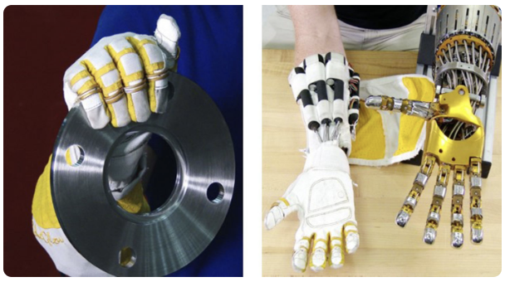

**Technical Information:**

Robo-glove is a self-contained glove which means actuators, pressure sensors, and synthetic tendons are embedded. Also, this design is ergonomic because the system helps reduce muscle strain from repetitive motion tasks. A lithium-ion battery, such as one for power tools, is used to power the system and is worn separately on the belt.

**Comparing to our project:**

Both our project and robo-glove provide assistive holding for industrial workers. However robo-glove does not provide temperature feedback. Our project provides temperature feedback which can ultimately let user detect the temperature changes and also prevent user from getting burned because we limit the amount of heat that is generated from the Peltier Cooler.

5.2.2 Commercial Product #2:

HaptX

<https://haptx.com/>

HaptX introduces the world’s first industrial-grade haptic gloves. HaptX Gloves bring realistic touch, powerful force feedback, and precise motion tracking to virtual reality

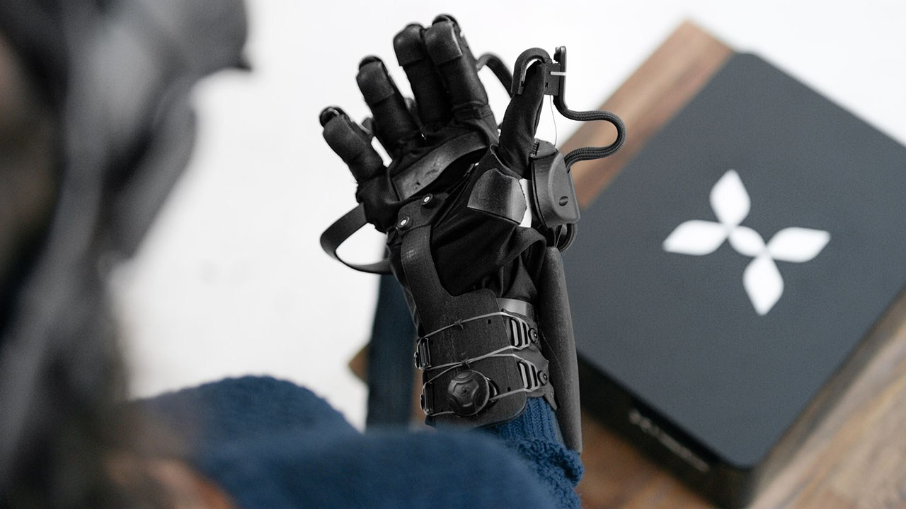

**Technical Information:**

Microfluidic smart textile: about 200 tactile points with optional hot and cold water temperature feedback layer

force-feedback exoskeleton provides five pounds of resistance to each finger

six degrees of freedom per finger motion tracking

Comparing to our project:

It has most precise textile feedback in the market and will be much precise than our project.

Both our project and HaptX have exoskeleton to apply resistive force on each fingers.

Its microchannel layer can provide limited temperature feedback with flowing water. Implementing with Thermoelectric semiconductors, our project will be able to provide more precise and quick temperature feedback to user’s hands.

Comparing to our project this product is neither portable nor wireless, must cooperates with a massive control box.

5.2.3 Commercial Product #3:

**Model G-LD Telemanipulator**

<http://crlsolutions.com/products/telemanipulators/one-piece/>

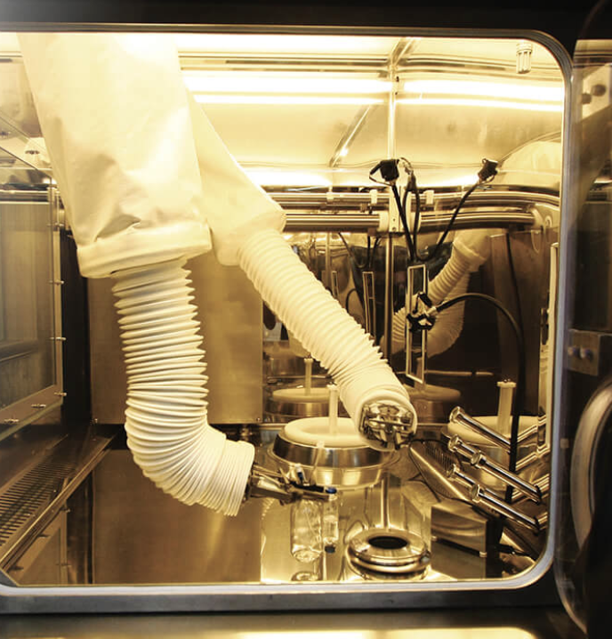

**Technical Information:**

Interchangeable tong jaw to handle different devices or glassware.

10 lb lift capacity.

Relatively compact design that could be utilized in small gloveboxes.

**Comparing to our project:**

G-LD is the the typical representation of telemanipulator products, which focus on the lift capacity and application environment. Comparing to our project, it has a better lift capacity and equips with external shielding for working under radioactive environment. However, our project has a higher degree of freedom that mimics the movement of human hand, combining with the temperature and touch feedbacks, our project would provide users a more immersive using experience just like operating with their own hands.

5.3 Open Source Project Analysis:

5.3.1 Open Source Project #1:

**InMoov Power Glove**

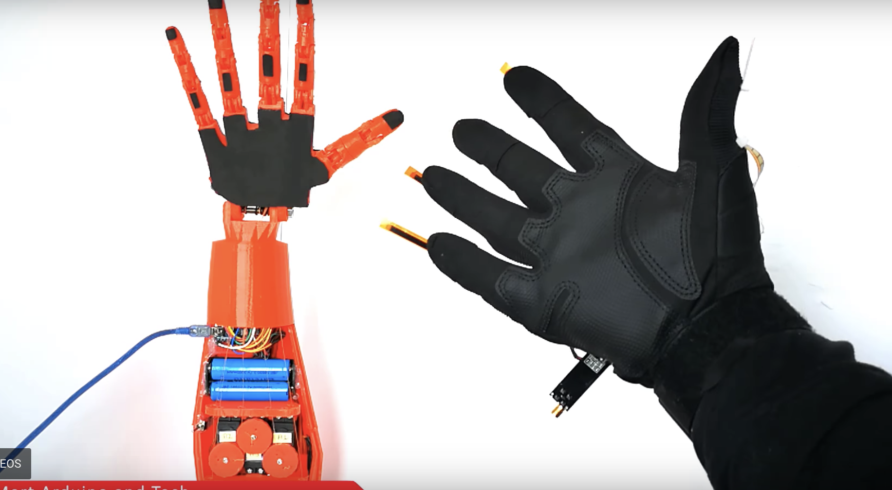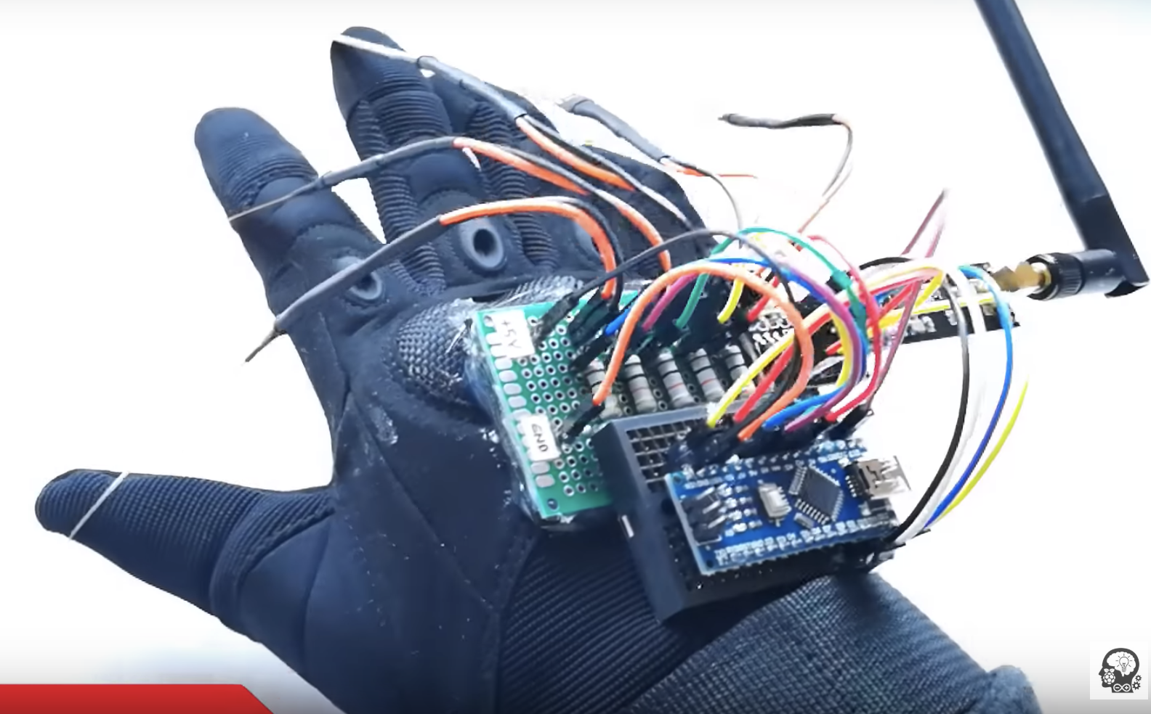

This is an open source project that is developed by the French sculptor, Gael Langevin. His project is closely related to our idea but there are some pro and cons between the two projects. For example, there is a series of ‘tendons’ that are being used to mimic the real hand gesture. Each finger is designed to move like human’s three-joints finger by utilizing smart mechanical design and Arduino to control the servo. Servos are located at the forearm which makes a lightweight robot hand. But the robot hand is unable to transmit heat or pressure signal back to the glove. Thus, our design is more beneficial and we can learn from their mechanical design to mimic the 3 planes movement of each finger.[4]

5.3.2 Open Source Project #2:

**Low-cost Sensor Glove with Force Feedback for Learning from Demonstrations using Probabilistic Trajectory Representations**

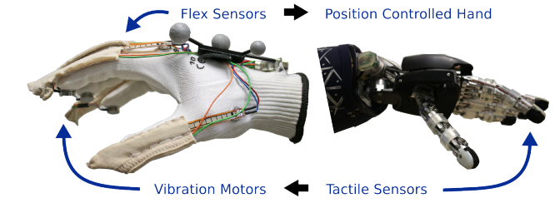

This open source project [5] is developed by Elmar Rueckert etc. The project is closely related to our idea, with the consideration of using the sensor gloves for a large variety of applications. In addition to the force feedback in this project, we are planning to add temperature sensors since many applications would require the user to “feel” the heat emitting from the object. The software interfacing in this project is particularly useful to our project. In this project, the use of serial communication on an arduino board is similar to what we have learned in the past. The pros of this project is that they used the glove to teach a robot to stack two plastic cups, it is different from the application that we are planning to use but we could utilize the force feedback in this to better adjust our project. The cons of this project is that it does not really consider a lot of joints used in the glove. It would be ideal to have more flex sensors in order to present proximal movement.

5.3.3 Open Source Project #3:

**Dextra**

<https://hackaday.io/project/9890-dextra>

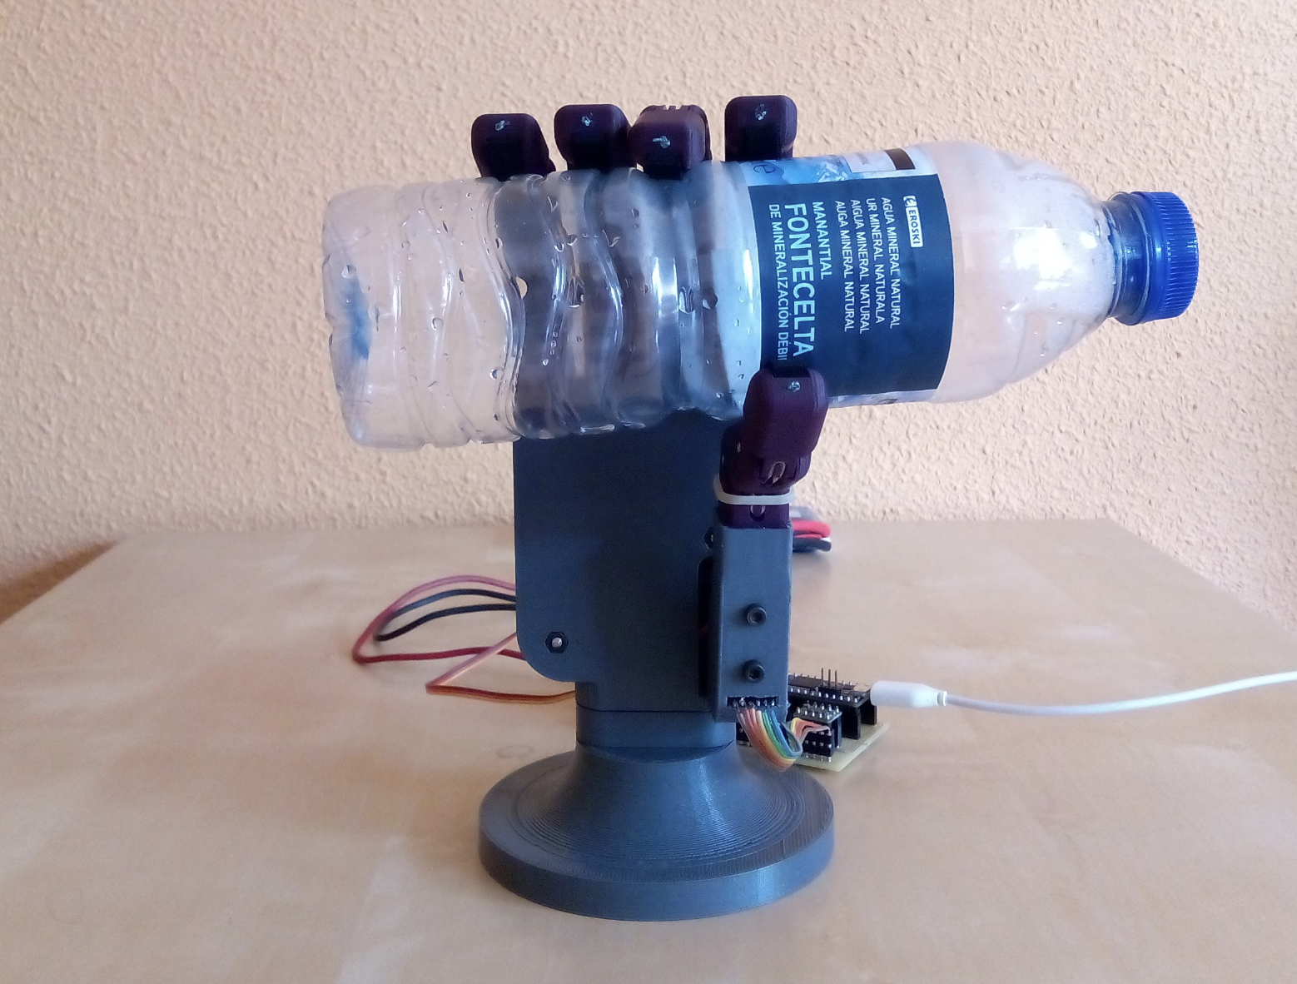

Dextra is a printable human-sized robotic hand that is being developed as a part of a personal project aimed to develop an open-source and affordable robotic hand prosthesis. The key design points of Dextra are: adaptive grip, compact size, mechanical simplicity and ease of replication.

The main element of Dextra is the finger module. The hand is modular: the four fingers are interchangeable, and the thumb is a variation of the finger module. The finger module comprises the printable mechanical finger, the actuator and an encoder. The compact actuator uses a DC micro gearmotor to rotate a spool that winds a fishing line, converting the rotational motion of the motor into a linear motion.

The position of each finger module is controlled by a PID loop that uses the value provided by the magnetic encoder of the DC motor as the feedback signal. For the DC motor as the feedback signal is a good idea for us to use in our project. But to get the requirement of course 477, our project will change the board from PID loop to the STM32 microcontroller as our main part to control our robotic hand. In the open source project, to be controlled by an amputee, Dextra uses a EMG interface that uses the user's myoelectric signals as the high-level control input. But for us project, the interface prefer to use force by our real fingers as the input to control and PWM to control the moving speed and GPIO to control the different finger parts of the robotic hand. it is easier to control and test in the real experiment.

6.0 Sources Cited:

[1] *Control of a Glove-Based Grasp Assist Device*.

[2] Liang, Xie. *Intelligence Gloves and Biomimetic Mechanical Hand Based on Synchro Control*. 10 Aug. 2015.

[3]*Tactile Feel Apparatus for Use with Robotic Operations*.

[4] M. Kılıç, “Robotic Hand With Wireless Glove Controlled | NRF24L01 | Arduino,” Instructables.com, 10-Jun-2018. [Online]. Available at: *https://www.instructables.com/id/Robotic-Hand-With-Wireless-Glove-Controlled-NRF24L/*

[5]Rueckert, E. (n.d.). Low-cost Sensor Glove with Force Feedback for Learning from Demonstrations using Probabilistic Trajectory Representations (Tech.).

[6]Laboratory Safety Culture Survey 2012 – Draft Report. (2012). [PDF] Laura Harper and Fiona Watt, Nature Publishing Group. Available at: *http://www.bioraft.com/sites/default/files/uploads/Lab_Safety_Culture-draft_report.pdf*

Appendix 1: Concept Sketch

